Assessment Task 2

Outcome 2

Create a basic mobile app. Analyse the requirements and produce a design document. It should declare whether it is a web or native app. It should include a navigational map, screen layouts – including any variations for size and orientation. It should show how you plan to maximise the usability and accessibility of the app. There should also be justifications of the design’s ability, accessibility and functionality including advantages and disadvantages of the used techniques.

Once confirmed it should include:

A launcher icon for native apps with multiple resolutions if required. A splash screen, an appropriate navigation system including exit controls, home screen including designs and four information screen for public or tourist interest which also contain designs.

Information can be collected from council websites or any other relevant means. All created material should conform to design guidelines for the specific platform. Should be 1000 words!

# Application: Ayrshire Helper

## Application Summary:

Ayrshire Helper will be an application which will give the user useful local information, whether they be a resident or a tourist. Residents will be able to check the locations of recycling centres as well as council locations and methods of contact by navigating to the relevant screens. Tourists will be able to look for local places to eat, hotels and B&B’s as well as learn a little of the history of the area by navigating to relevant slides. There will also be an important times page which will contain information about local festivals and events which happen and their dates.

The application will be a native app to Android as opposed to a web app. This is because it will not require an online connection to use as well as the ability for the app to be built and optimised for android systems instead of being a generalised application.

### Navigation and Pages:

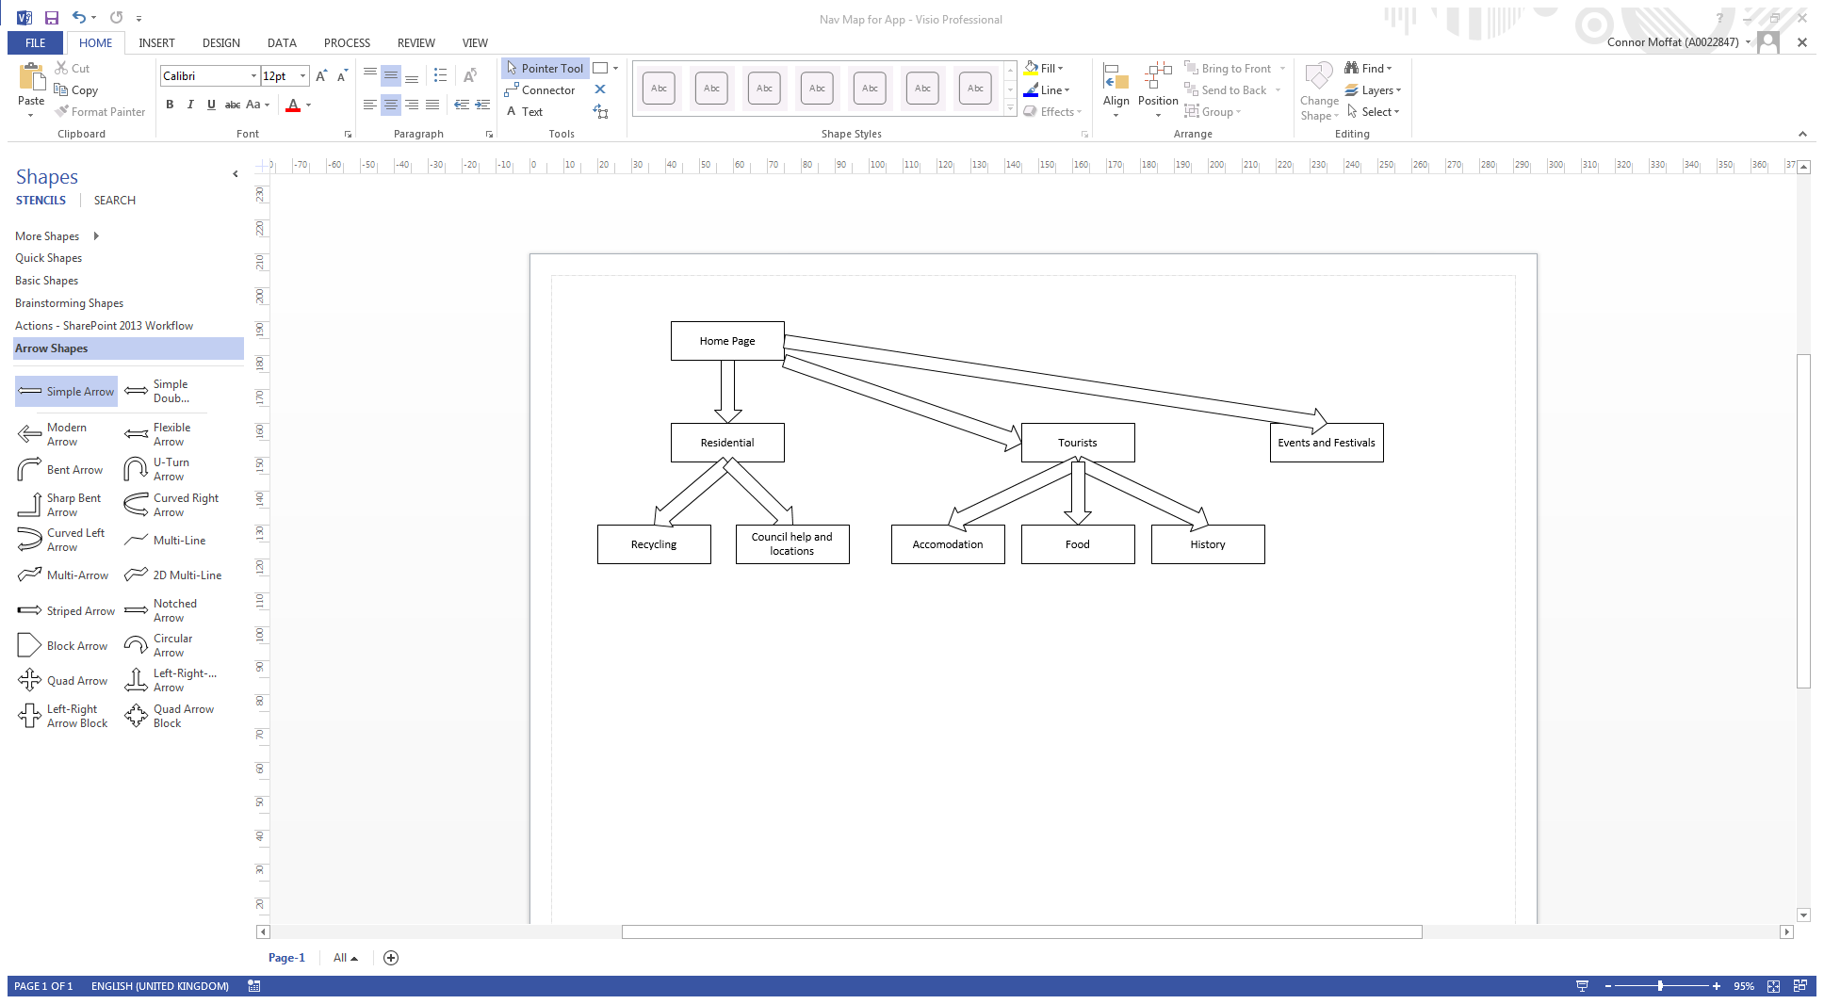

#### Home Page

The home page will be the user’s introduction to the app. Here they will get a short summary of the applications functionality and be able to start navigating throughout the app.

#### Residential

The Residential page will give the user a summary of basic residential information as well as the ability to navigate to further information.

##### Recycling

The Recycling page will contain the information pertaining to the location of recycling centres as well as their working hours. It will also contain information related to locating and navigating to the recycling points.

##### Council help and locations

Council help and locations will contain the locations of the local council branches, their address and working hours. It will also inform the user on methods available to get in contact with each council branch.

#### Tourists

The Tourist page will contain a summary of basic information that would be relevant for a tourist as well as the ability to navigate to further information.

##### Accommodation

The accommodation page will contain information on local hotels and Bed and Breakfasts. It will contain information pertaining to the opening hours as well as contact information and locations of each establishment.

##### Food

The food page will contain information of restaurants that are local. The information will include opening hours, location and cuisine type of each establishment.

##### History

The history page will have summaries of local history as well as the locations and summaries of local landmarks and areas of historical significance.

#### Events and Festivals

The events and festivals page will contain a list of important events that happen over the course of a year, what they are and when they are. There will be summaries of each event as well as any historical significance that they might hold.

## Accessibility: